**DISCUSSION FORUM WEBSITE**

**S. E. Information Technology**

By

**Shreyansh Doshi 28**

**Amarjit Gupta 36**

**Jay Gupta 37**

**Asit Shigwan 64**

Mentor:

**Name of the Mentor**

Mrs. Amrita Mathur



Department of Information Technology

St. Francis Institute of Technology

(Engineering College)

University of Mumbai

2020-2021

**DECLARATION**

We declare that this written submission represents our ideas in our own words and where others' ideas or words have been included, we have adequately cited and referenced the original sources.

We also declare that we have adhered to all principles of academic honesty and integrity and have not misrepresented or fabricated or falsified any idea/data/fact/source in this submission.

We understand that any violation of the above will be cause for disciplinary action by the Institute and can also evoke penal action from the sources which have thus not been properly cited or from whom proper permission has not been taken when needed.

1.-----------------------------------------

Shreyansh Doshi (28)

2.-----------------------------------------

Amarjit Gupta (36)

3.-----------------------------------------

Jay Gupta (37)

4.-----------------------------------------

Asit Shigwan (64)

Date:

**CERTIFICATE**

This Python Mini-project “Discussion Forum Website” by Shreyansh Doshi(28), Amarjit Gupta(36), Jay Gupta(37), Asit Shigwan (64) is complete in all respects and was successfully demonstrated on {Final external presentation date}.

Name: ---------------------------------------------

Signature:------------------------------------------

(Internal examiner)

Name: ---------------------------------------------

Signature:------------------------------------------

(External examiner)

Date:

Place:

**CONTENTS**

|  |  |  |
| --- | --- | --- |
| **Chapter No.** | **Chapter Name** | **Page Number** |
| 1 | Introduction |  |
| 2 | Literature Review |  |
| 3 | Problem Statement |  |
| 4 | System Design and Requirements |  |
| 5 | Results |  |
| 6 | Conclusion and Future Scope |  |
|  | References |  |
|  | Papers published/ Participations/ Awards |  |

**Chapter 1**

**Introduction**

In today’s world online platforms are emerging rapidly and in this lockdown scenario, people are away from their classrooms and offices. Which means people get solutions to their problems by discussing online. That’s where the idea of Discussion forum comes in picture. The use of online discussion forum has emerged as a common tool and an effective way of engaging students outside the classroom.

An online forum or a message board is a public place where you can drop any message, or discuss about any particular topic. The forum allows you to register with it and after that you can look into the answers to various questions written by others or you yourself can answer the questions.

There are large number of people willing to reply to new topics, and seek answers to their questions. This is where our Discussion forum website will be useful for people. The website is less complex and easy to handle. The users will be able to exchange information and discuss on topics without any hassle and in an user friendly way.

**Chapter 2**

**Literature Review**

|  |  |  |  |  |
| --- | --- | --- | --- | --- |
| NO | Author | Paper Name | Year | Discription |
| 1 | Wright, S., & Street, J. | Democracy, deliberation and design: the case of online discussion forums. New Media & Society | 2007 | Description:  The authors have discussed about the nature of deliberative democracy and the way the Internet can be a used as a means of increasing citizen participation in policymaking via deliberation amongst each other and by directly addresing policymakers using discussion forums. The paper also analyzes the impact of the medium of deliberation, i.e, the discussion forum and how the design of the forums, along with the nature of the moderation as well as political and aesthetic motivations of the designers and the creators, influences user behavior, thus making the case for ‘choice architecture’ prior to Thaler and Sunstein, and they validate the same via comparison of various user generated threads on AOL, UseNet and Futurum, in which the forums were compared on the basis of the level of deliberation they induced. The authors, on the basis of the comparison, came to the conclusion that while they did not believe this was a case of technological determinism, the design choices did influence the outcome and success of the discussion forums as a means of fostering deliberation among the citizenry. |
| 2 | Ravi Seethamraju | Effectiveness of Using Online Discussion Forum for Case Study Analysis. | 2014 | The paper deals with the question of the efficacy of a blended study model (a mix of asynchronous and in-person study methods) facilitated by an online discussion forum in a business school setting using a case study pedagogical method. The author points out that while there are split opinions regarding the benefits of an online delivery method of content using discussion boards and other means (e.g LMS or CMS), there is extensive potential in the same. The primary corncerns raised by other scholars about such online learning methods were the lack of in-person interaction between the professors and the students, fear of judgement in students regarding exposure of lack of knowledge on a rather public forum as well as the problem of a few students dominating the entire discussion, in turn silencing other students.The author also cited a lack of research specific to the impact of online discussion forums used as a method of assessment in a business course using the case study pedagogy. The author conducted an experiment in which an online discussion forum was used as a means of assessing students in order to have a meaningful number of participants, which would in turn create a relatively reliable data set. The responses on the discussion forum were analyzed on the basis of certain characteristics which would measure both the quality of collaboration between students as well as the effectiveness of learning by the student using the discussion forum. After analyzing the data set and comparing to a previous batch of students who were studied the course in a purely in-person mode, it was found that students who studied using the blended method scored higher grades than their in-person counterparts and the author concluded that while more research is needed in this area, the experiment showed that there was a significant improvement in the learning experience using online discussion forums based on both the improvement in grades as well as informal and formal feedback from the students. |
| 3 | A qualitative analysis of an Internet discussion forum for recent ex-smokers. Nicotine & Tobacco Research | A qualitative analysis of an Internet discussion forum for recent ex-smokers. Nicotine & Tobacco Research. | 2006 | The paper deals with a study conducted by the authors on an online discussion forum dedicated to ex-smokers and prospective ex-smokers. The conventional treatment regime of tobacco dependence involves social and psychological support. However, the stigma surrounding the same means that there are less opportunities of ex-smokers to find other ex-smokers anywhere except for the Internet. The availability of such discussion forums also dissolves the fear and hesitance of recent ex-smokers, as well as relapsed and prospective ex-smokers to seek help with regards to various psychological and physical symptoms of withdrawal. The authors set out to find what kind of an impact does a discussion forum of this sort have on the ex-smokers’ psyche and whether it actually is a helpful tool to encourage people to kick the habit. A study was conducted in which a particular ex-smokers’ discussion forum was analyzed for a period of one month and the content was categorized and coded. The analysis of the data showed that most posts and comments were made in the category of “Emotional support”, followed by “Stories/Anecdotes/Personal Experience” and “Congratulations”. 10 most active members accounted for 49.8% of the content and majority of the content was posted by women. The study also reaffirmed the commonplace belief that men are practical and women are emotionally well attuned as women gave most content in “Emotional Support” category, while men were more active in the “Tips/Practical tricks” category. The authors concluded that while there was no observable benefit brought by the online discussion forum, it should be leveraged as a method to provide peer-to-peer support to ex-smokers and smokers alike. |
| 4 | Zheng, X., Lai, Y. M., Chow, K. P., Hui, L. C. K., & Yiu, S. M. | Sockpuppet Detection in Online Discussion Forums. | 2011 | This paper deals with the detection of ‘sockpuppet’ accounts,i.e different accounts owned or created by the same person/entity, on discussion forums. The first scenario considers the sockpuppets existing on the same forum, in which case they tend to self-promote or promote a particular thing repeatedly so as to create the effect that multiple individuals are talking about the same issue hence increasing the visibililty of the topic as well as the posts of the sockpuppet accounts. The second scenario deals with the issue of sockpuppet accounts on two different forums. In this case, the content was analyzed to check the commonality of topics on which two accounts have interacted on and the time interval between the posts of the two accounts on the said topics. Another characteristic used is the fact that sockpuppet accounts don’t stay active for long, hence the time difference between the first and last post has been used to improve the accuracy of the detection method.  . |

**Existing Systems:**

* **Quora :** Quora is an internet discussion forum with a question and answer format. One can ask questions related to various topics, search for previously asked questions and also upvote or downvote answers accordingly to their accuracy and veracity. A user can also subscribe to various topics which will show all the questions asked pertaining to the topic or closely related to it. A user can also answer various questions, anonymously or otherwise.
* **StackOverflow:** The website serves as a platform for users to ask and answer questions, and, through membership and active participation, to vote questions and answers up or down and edit questions and answers in a fashion similar to a wiki or Reddit. Users of Stack Overflow can earn reputation points and "badges"; for example, a person is awarded 10 reputation points for receiving an "up" vote on a question or an answer to a question, and can receive badges for their valued contributions, which represents a gamification of the traditional Q&A site. Users unlock new privileges with an increase in reputation like the ability to vote, comment, and even edit other people's posts.
* **Reddit:** Reddit is a social media and discussion forum where registered members submit content to the site such as links, text posts, images, and videos, which are then voted up or down by other members. Posts are organized by subject into user-created boards called "communities" or "subreddits", which cover a variety of topics such as news, politics, religion, science, movies, video games, music, books, sports, fitness, cooking, pets, and image-sharing. Submissions with more up-votes appear towards the top of their subreddit and, if they receive enough up-votes, ultimately on the site's front page. Despite strict rules prohibiting harassment, Reddit's administrators have to moderate the communities and, on occasion, close them. Moderation is also conducted by community-specific moderators, who are not considered Reddit employees.

**Chapter 3**

**Problem Statement**

To create a discussion forum website using Django-a Python based framework and PostgreSQL database for backend and HTML, CSS, JavaScript for frontend. The site will have a register and login page through which users can create an account or access their account. Users can post new questions on website, which can be viewed and answered by other users. Users can reply with valuable feedback and suggestions to the questions posted on the forum. Users can also like the questions posted on site.

**Chapter 4**

**System Design and Requirements**

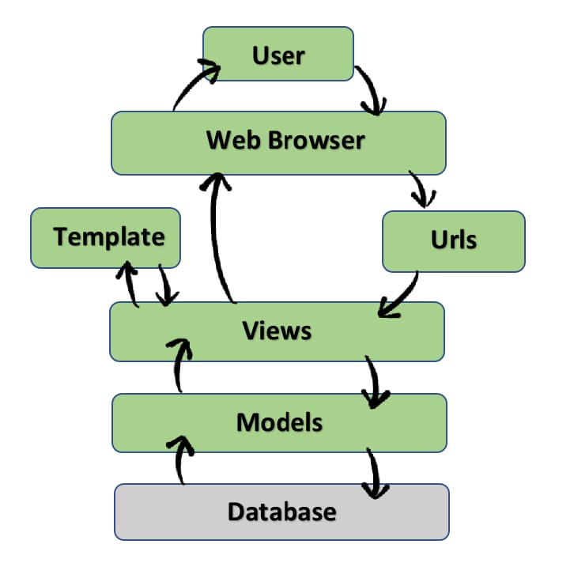

**System Requirements**

**For System designer:**

**Software:**

Pycharm or Visual Studio Code

PostgreSQL

Pgadmin4

Browser: Google chrome (or other)

OS: Windows 7 or higher

**Hardware:**

CPU: 64 bit Intel or Amd processor

Ram: 4GB or above

OS: Windows 7 or above

**For Users:**

**Software :**

Web browser(chrome or other)

**Hardware:**

CPU : Intel pentium or AMD processor

Ram : 4GB or above

**Chapter 5**

**Results**

**Chapter 6**

**Conclusion and Future Scope**

**Conclusion:**

The goal of the project is to create a user friendly and accessible site where the users can easily exchange information and share their ideas with one another. Throughout this semester the team has decided and finalized the project topic and worked on its plan, design and how it has to be implemented while following the project guidelines. Approval and evaluation of the project was done online.

**Future Scope:**

In future we can expand this project by adding services like

* We can upgrade the system from web based to cloud based.
* We can group topics of similar interest under one category.
* We can add search bar and search for posts using certain keywords.
* We can add a feature to follow an account or a page.
* Users can create separate rooms/groups for discussion on a particular topic.

**References**

1. <https://www.youtube.com/watch?v=OTmQOjsl0eg>
2. <https://docs.djangoproject.com/en/3.2/>
3. <https://www.youtube.com/watch?v=kRrPtIjnxqs&list=PLgjw1dR712joFJvX_WKIuglbR1SNCeno1&index=16>
4. <https://spoken-tutorial.org/tutorial-search/?search_foss=Python+Django&search_language=English>

**Papers Referred:**

1. Wright, S., & Street, J. (2007). Democracy, deliberation and design: the case of online discussion forums. New Media & Society, 9(5), 849–869. doi:10.1177/1461444807081230
2. Seethamraju, R. (2014). Effectiveness of Using Online Discussion Forum for Case Study Analysis. Education Research International, 2014, 1–10. doi:10.1155/2014/589860
3. Burri, M., Baujard, V., & Etter, J.-F. (2006). A qualitative analysis of an Internet discussion forum for recent ex-smokers. Nicotine & Tobacco Research, 8(1), 13–19. doi:10.1080/14622200601042513
4. Zheng, X., Lai, Y. M., Chow, K. P., Hui, L. C. K., & Yiu, S. M. (2011). Sockpuppet Detection in Online Discussion Forums. 2011 Seventh International Conference on Intelligent Information Hiding and Multimedia Signal Processing. doi:10.1109/iihmsp.2011.69

**Papers Published/ Participations/ Awards**

*(Write only whatever is applicable to you)*